**Programs:** [**https://citria.org/programs/mern-stack-web-development**](https://citria.org/programs/mern-stack-web-development)

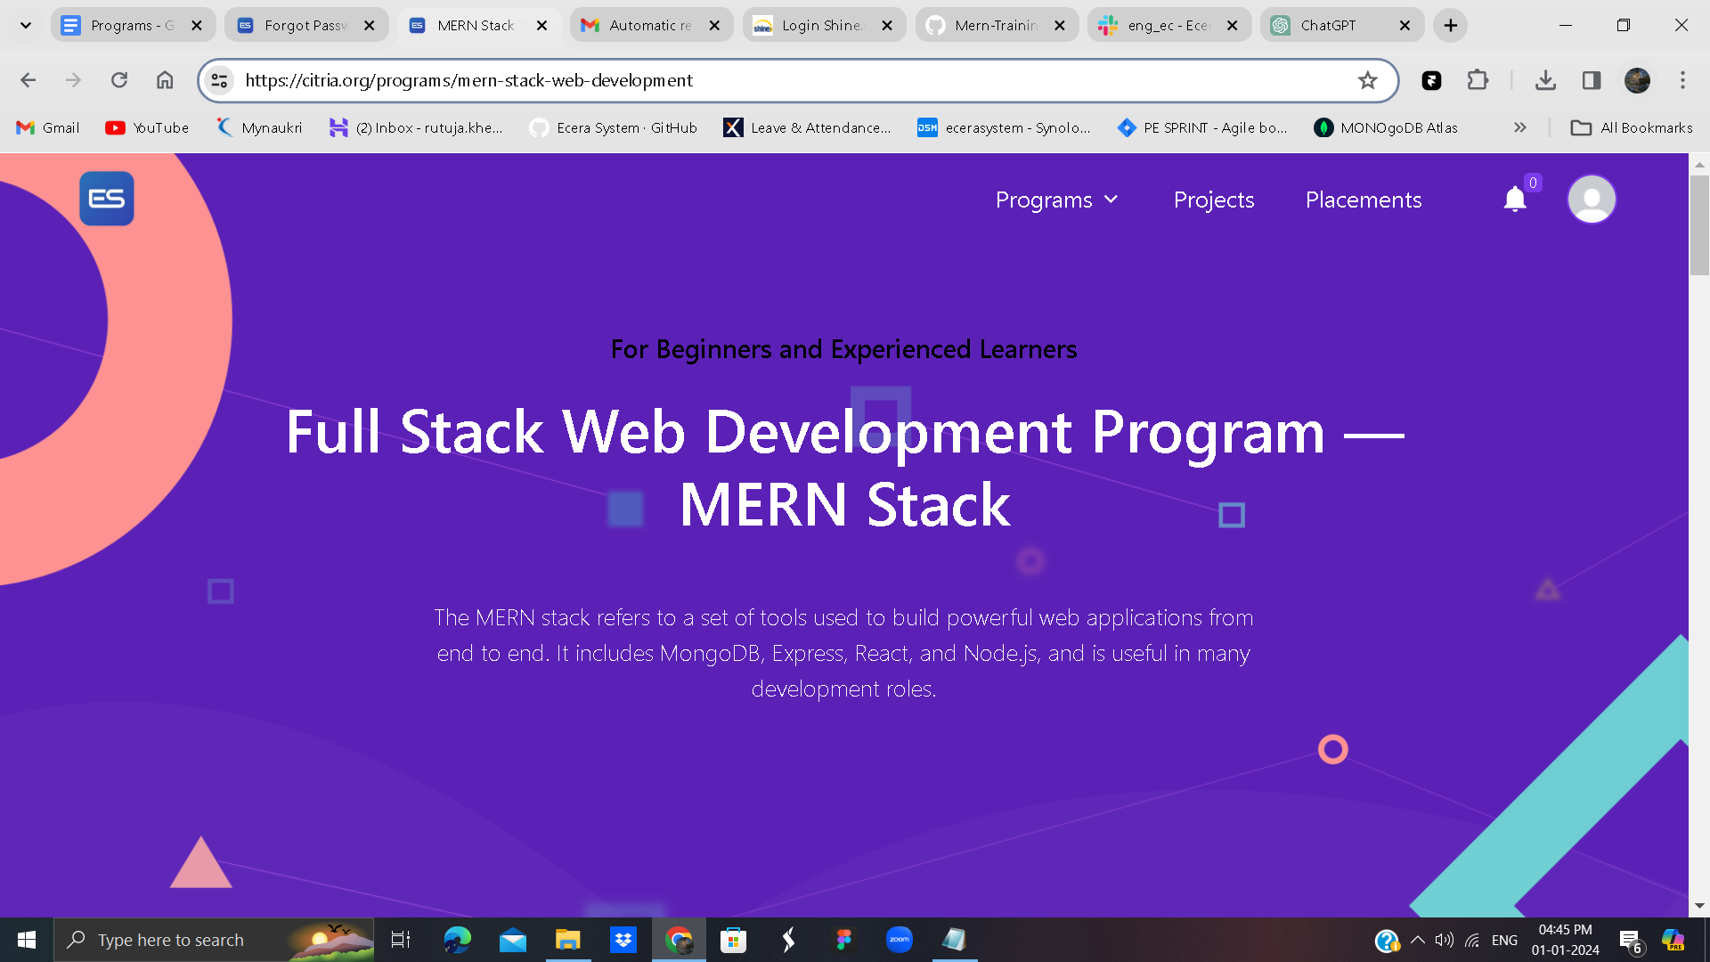

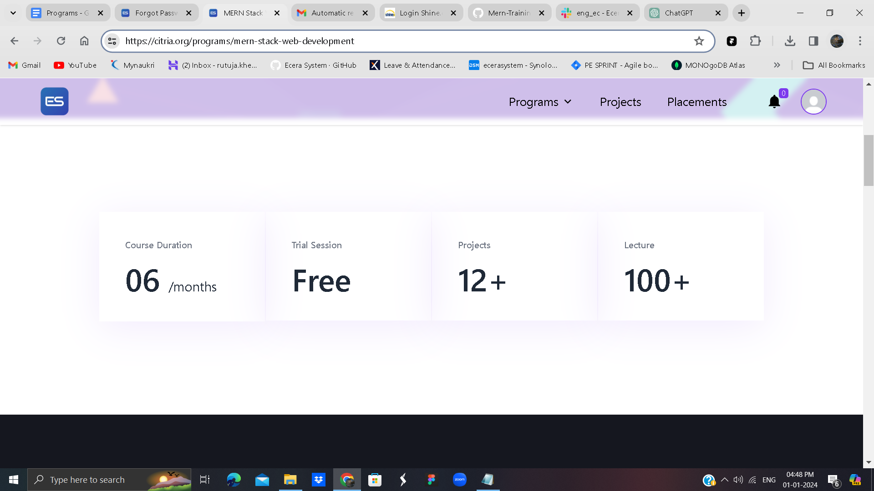

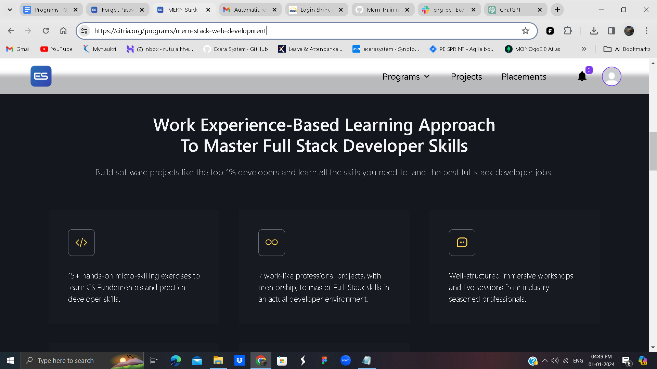

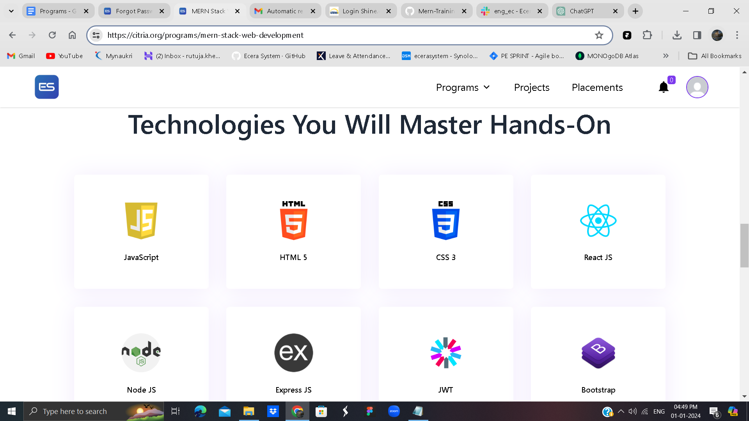

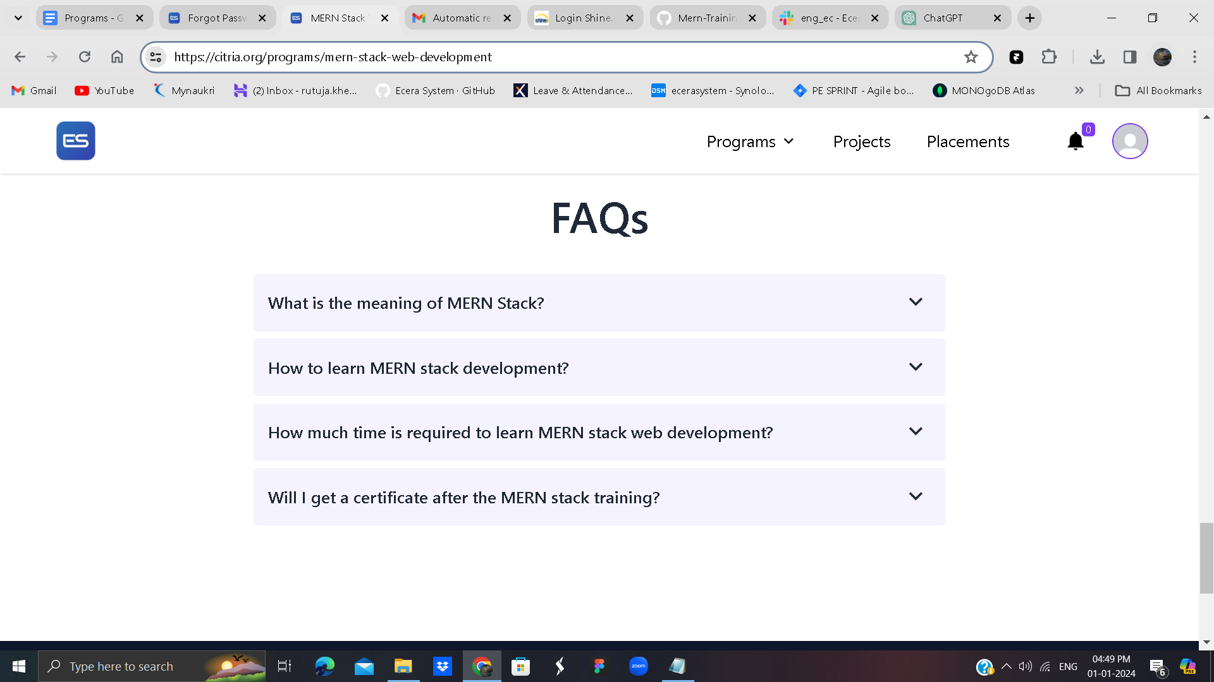

The provided code is a React component named MERNStackWebDevelopment that represents a web page or a section of a web page dedicated to a MERN (MongoDB, Express.js, React.js, Node.js) Stack Web Development program. Let's break down the key parts of the code:

Import Statements:

The component uses various icons from different libraries like react-icons/hi, react-icons/hi2, react-icons/tfi, react-icons/bi, react-icons/vsc, and react-icons/bs.

It imports React hooks (useState), components (Footer, PageTitle, Header), and functions (useNavigate, useGetAllCourses) from React and other custom modules.

State and Hooks:

useState is used to manage the state of indexFaq (the index of the FAQ being displayed).

useGetAllCourses is a custom hook that fetches course data.

Router and Navigation:

The useNavigate hook is used for programmatic navigation in React Router.

The Link component from react-router-dom is used to create a link to an external contact page.

Fetching Course Information:

The code attempts to find the current course based on the URL pathname using data fetched by the useGetAllCourses hook.

Rendering Sections:

The component is divided into several sections, each representing a part of the web page.

The sections include information about the course, course duration, trial session, projects, work experience-based learning approach, technologies to be mastered, a contact section, and frequently asked questions (FAQs).

Styling:

Tailwind CSS classes are used for styling, including responsive design for different screen sizes.

Conditional Rendering:

Certain elements, like the "Enroll Now" button, are commented out but can be enabled based on the availability of course data.

FAQ Section:

Frequently Asked Questions (FAQs) are displayed in an unordered list, with each question having an expandable answer.

Footer:

The Footer component is included at the end of the page.

External Links:

There is a link to an external contact page.

Background Images:

Background images are used for styling certain sections.

Please note that the specific functionality and appearance of the component depend on the implementation details of the custom hooks (useGetAllCourses) and the imported components (Footer, PageTitle, Header). Additionally, the code is written using Tailwind CSS for styling and assumes the usage of React Router for navigation.